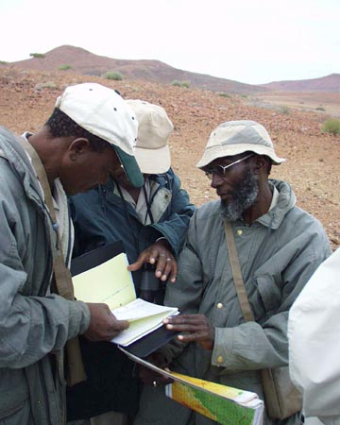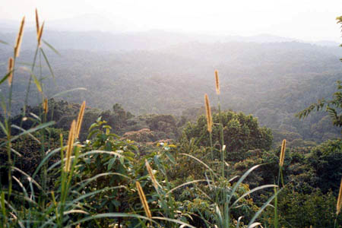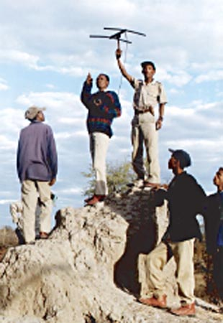
ABCG
MEETING
Photo credit: (c) USAID Photo credit: (c) M. McGahuey Photo credit: (c) USAID
USAID

CONSERVATION MEASURES PARTNERSHIP (CMP) UPDATE:
MANAGEMENT EFFECTIVENESS AND STATUS MEASURES

DRAFT
MEETING AGENDA

DATE: Tuesday, 29 November 2005

TIME: 9:30am to 12:30pm

LOCATION: World Wildlife Fund
1250 24th St, NW, Washington, DC 20037
Conference Rooms 2004 B & C

CHAIR: Lynn Foden, African Wildlife Foundation (AWF)

MEETING OBJECTIVES:
- To learn how the Conservation Measures Partnership (CMP) is working to advance the practice of conservation by developing, testing, and promoting principles and tools to credibly assess and improve the effectiveness of conservation actions.
- To get an overview and discuss two primary focal areas of work on Management effectiveness (Open Standards and Conservation Audits) and Status measures.
- To understand how different non-governmental organizations (NGOs) are integrating standards and measures into their conservation work.

AGENDA:

9:30-9:45am Welcome/ Introductions/ Review of Agenda
Lynn Foden, AWF

9:45-10:00am Overview on the Conservation Measures Partnership
Richard Margoluis, Foundations of Success
10:00-10:30am Discussion
10:30-10:45am Open Standards and Conservation Audits
Sarah Christiansen, World Wildlife Fund

10:45-11:15am Discussion

11:15-11:30am Status Measures
Elizabeth O’Neill, Conservation International

11:30-12:30pm Discussion

